PISA 2012 - Mathematics test result
in the context of
European educational performance by different measures

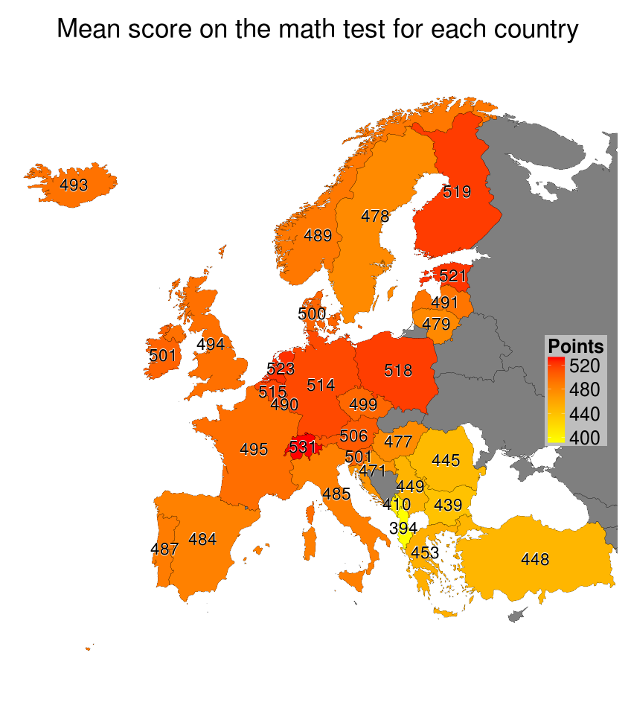
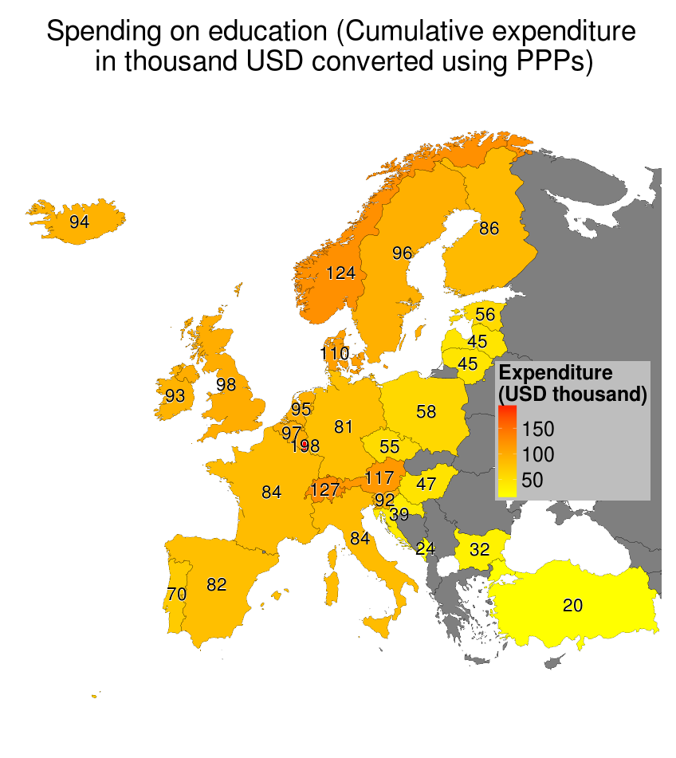

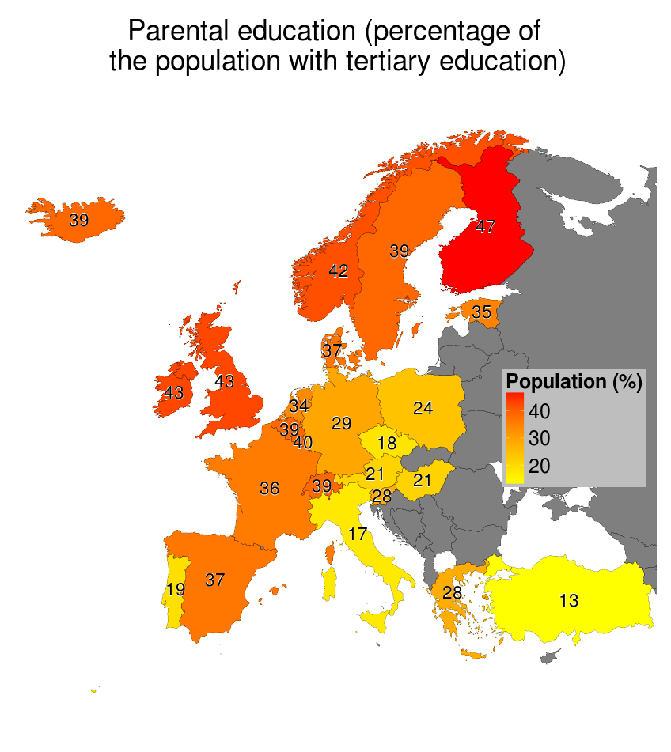
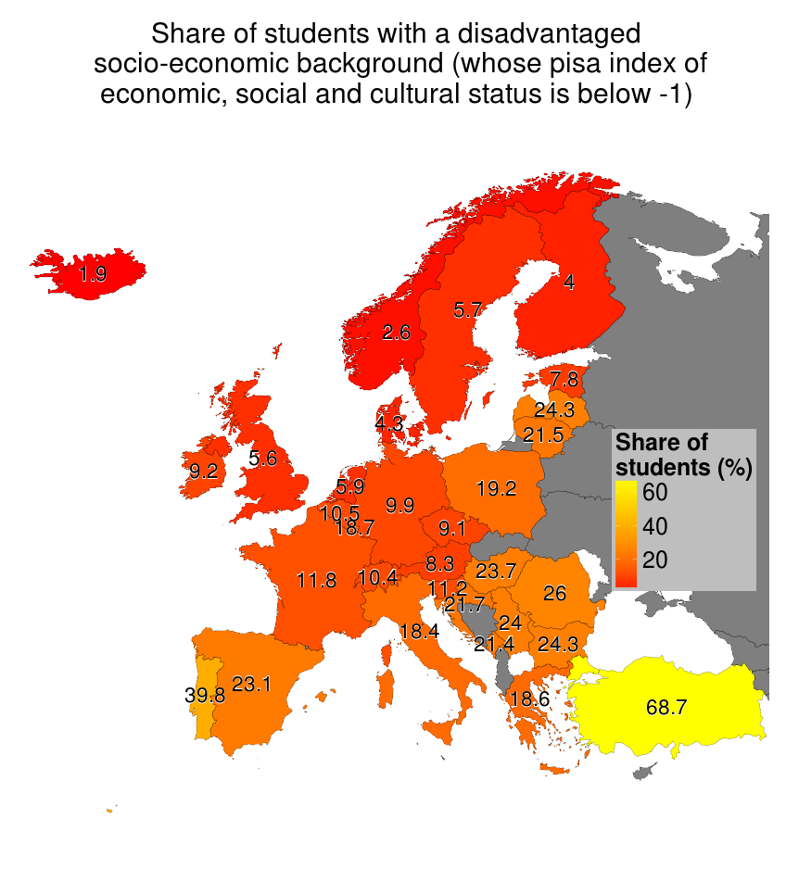

Authors:
Krzysztof Kiljan, Michał Woś
Sources:
http://www.theguardian.com/news/datablog/2013/dec/03/pisa-results-country-best-reading-maths-science
https://github.com/pbiecek/TechnikiWizualizacjiDanych/tree/master/MINI_MIMUW_2014/PISA/Faza%202/Kiljan_Wos

